Question 1 (15 Marks) Marks

(a) Given that α = 3 + 2i and μ = 2 – 5i, find
(i) αμ = (3 + 2i)(2 – 5i) 1mk
= 11 – 4i 1mk 2

(ii) Re(αμ) = 11 1mk 1

(iii) Im(αμ) = − 4 1mk 1

- Describe geometrically, on an Argand diagram

- Re(z) = 2. 1
y

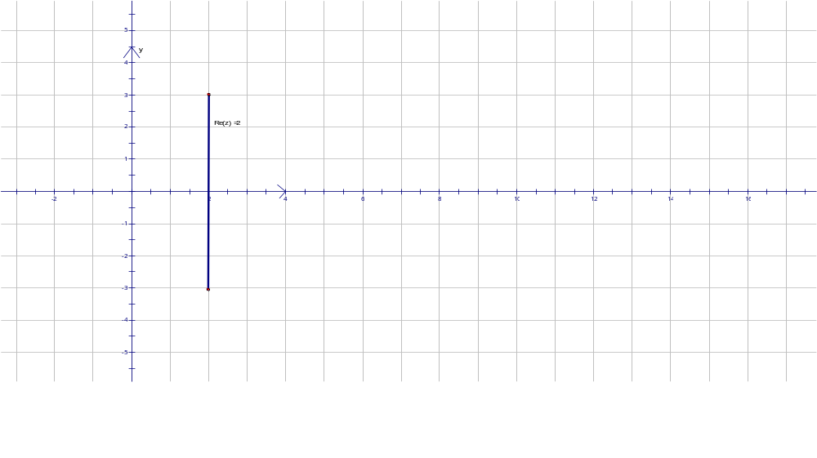1mk
x
1

- Im(z) < 2
1
y
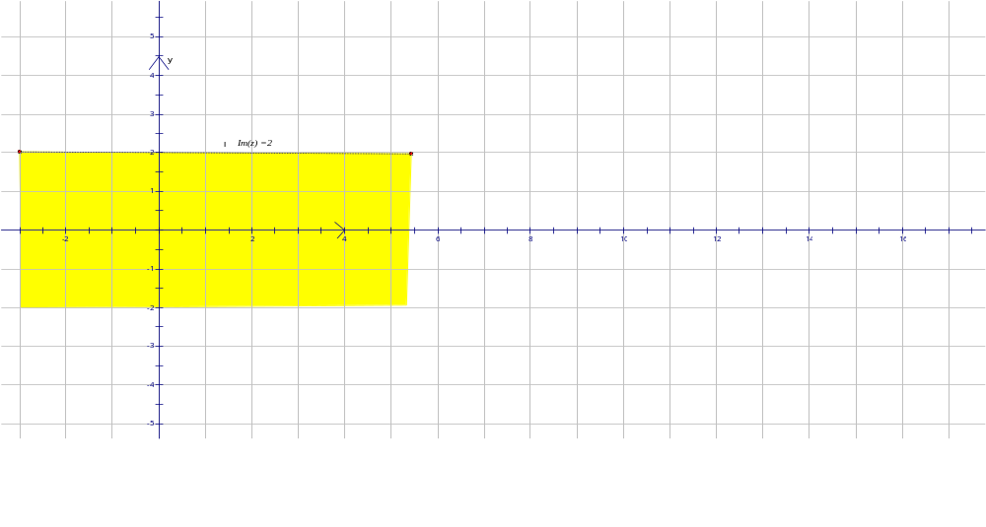1mk
x
(c) Expand and simplify 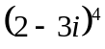 3
= 2⁴ + 4(2)³(−3i) + 6(2)²(−3i)² + 4(2)(−3i)³ + (−3i)⁴ 1mk
= 16 – 96i + 216i² – 216i³ + 81i⁴ 1mk
= −119 +120i 1mk
(d) Calculate the modulus of the product of the roots of the equation 3
(2 + i)x² + 3x – (1 – i) = 0.
Let the roots be α, β. Then αβ = 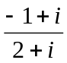 1mk
∴ αβ = 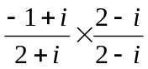
= 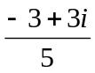 1mk
|αβ| = 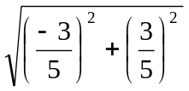= 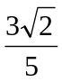 1mk

(e) Show that the point representing cos+ isin is on a circle with radius 1 3
and centre at (1, 0).
Let z = cos+ isin = 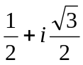
∴ |z| = 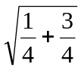= 1 ➔ equal to radius of circle 1mk

Now equation of the circle with centre (1,0) and radius 1 is (x – 1)² + y² = 1 1mk
Since x =  and y =  and substitution into LHS = 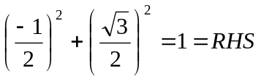 1mk
∴ cos+ isin lies on circle centred (1, 0) and radius 1.

Question 2 (15 Marks)
(a) The complex number z = 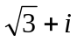is represented on an Argand diagram by the point A.
- The points B, C, D and E are the points representing −z, iz, 1 – z and 4
respectively. Mark clearly on an Argand diagram the points A, B, C, D, and E.
Clearly indicate important geometrical relationships between these points.

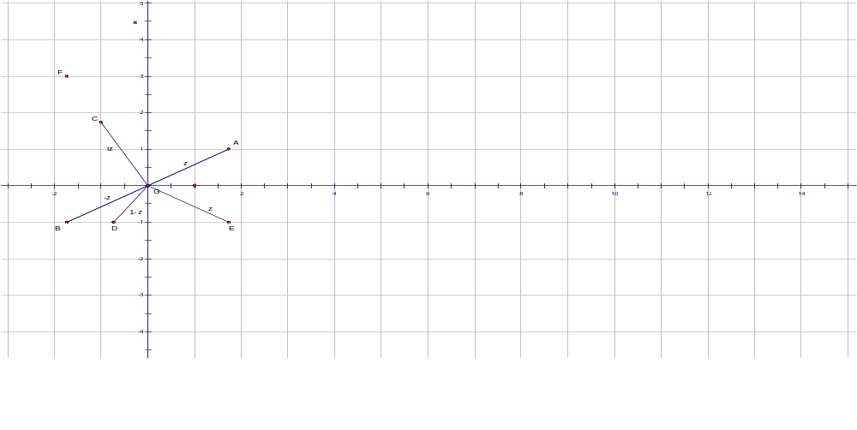
- Points B, C, D, E with relationship to point A, award 1mk each

- Just points award 2 marks only
- F is the point in the second quadrant such that ∆ABF is equilateral. 2
What complex number is represented by the point F?

F must be the same distance from A as B is so must have point (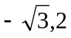)
So has the complex number z₂ = 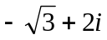 1mk

(b) (i) Find 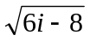, in the form a + ib. 3

Let ∆ = 6i – 8 then let ∆ = (a + ib)² where a, b are Real
∴ a² – b² = −8 and 2ab = 6 ∴ ab = 3 1mk

∴ 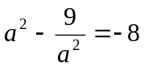 ➔ a⁴ +8a² – 9 = 0
(a² + 9)(a² – 1) = 0 since a is real ➔ a = 1 or a = -1 so b = 3 or b = -3 respectively. 1mk
∴ = 1 + 3i or −1 − 3i 1mk

(ii) Hence, solve the equation 2z² – (3 + i)z + 2 = 0, expressing the values of z 2
in the form a + ib.

∴ z = 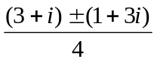 by quadratic formula 1mk
∴ z = 1 + i or z = 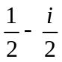 1mk

(c) A point z on the Argand diagram is given by z = w² + 2iw, where w = u + iv
and u and v are real. Find the locus of z when

- u = 0 and v varies. 1
when u = 0 then w = iv and z = −v² – 2v
if z = x + iy where x, y are real ∴ x = −v² – 2v and y = 0
∴ locus is y = 0 1mk

- v = 1 and u varies. 1
when v = 1 then w = u + i and z = (u + i)² + 2i(u + i)
∴ z = (u² – 3) + 4ui
∴ if z = x + iy where x, y are real then
x = u² – 3 and y = 4u ∴ y² = 16(x + 3) 1mk

- Sketch the two loci, showing any important features. 2

See next page 1mk each
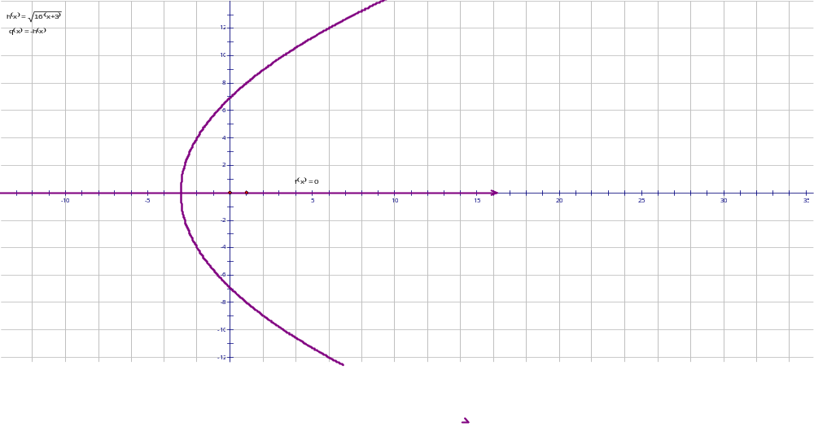
y² = 16(x+3)

Question 3 (15 Marks) Marks

(a) Sketch the locus |z + 2 – 3i| ≤ 5. 2
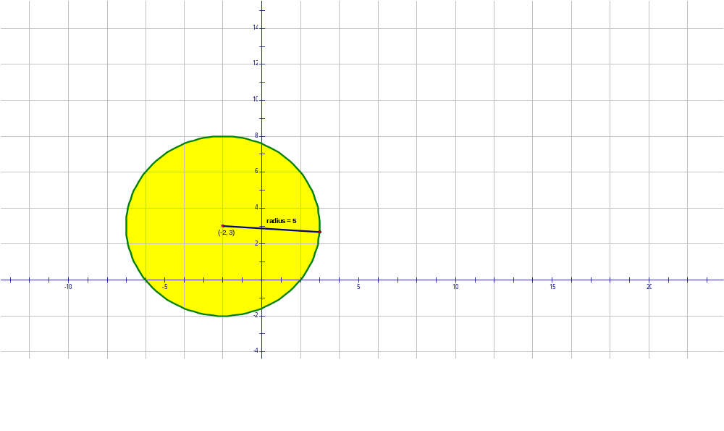
1mk for circle centre (−2,3) and radius= 5

1mk for correct region

(b) Show that w = 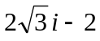 is a root of the equation z³ = 64. 2

w = = 4(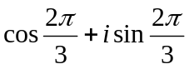) 1mk
∴ w³ = 4³ (cos 2π + isin 2π) by De Moivre’s Theorem
= 64 as required 1mk

(c) If z ≠ 0, show that u = z + 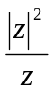 is always real, where z = x + iy and x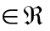 , y . 3
z = x + iy then |z|² = x² + y² & z² = (x² – y ²) +2ixy 1mk
Now u = z + = 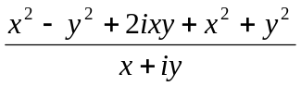 1mk
= 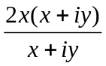 1mk
= 2x which is real as x is real
Alternatively:
u = z + = 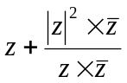 1mk
= 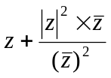 1mk
= z + 1mk
= x + iy + x – iy
= 2x which is real as x is real.

(d) If z = cosθ + isinθ, prove that 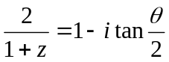. 3
LHS = 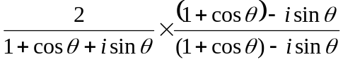 1mk
= 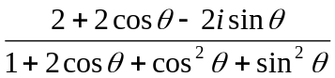

= 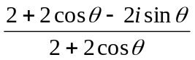
= 1 − 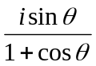 1mk
= 1 − 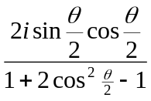 1mk
= 1 − 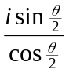
= 1 − itan 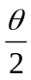 = RHS [Students could also let t = tan ]

(e) Sketch the region, in an Argand diagram where points satisfy the set of inequalities: 2
2 ≤ |z| ≤ 4 and 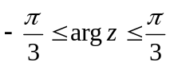.
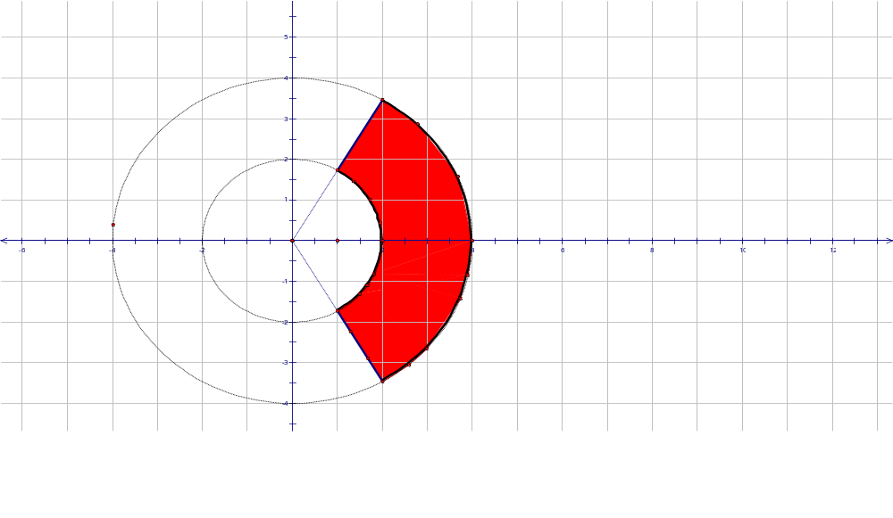
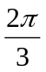
|z| = 4
|z| = 2
Arg(z) =
Arg(z) = -
1mk for the boundary

1mk for the region

(f) Prove that if Z₁, Z₂ are complex numbers then |Z₁ – Z₂| ² + |Z₁ + Z₂| ² = 2{|Z₁| ² +|Z₂| ²}. 3

LHS = |Z₁ – Z₂| ² + |Z₁ + Z₂|
= (Z₁ + Z₂)(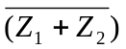 + (Z₁ − Z₂)(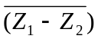 1mk
= (Z₁ + Z₂)(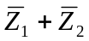) + (Z₁ − Z₂)( 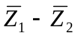)
= 2(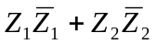) 1mk
= 2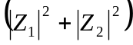 = RHS 1mk

Question 4 (15 Marks)
(a) 2 – i is one root of x² – (3 – i)x + k = 0. Find k and the other root of the equation. 2

Let α and β be the roots of the equation, so let β = 2 – i
∴ α + 2 – i = (3 – i) ➔ α = 1 1mk
∴ αβ = k ➔ k = 2 – i 1mk

(b) Sketch the region in the Argand diagram defined by 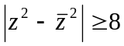 3
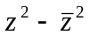 = (z – )( z + )
= (2iy)(2x) = 4ixy
∴ 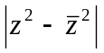≥ 4|xy|
∴ 4|xy| ≥ 8 ➔ |xy| ≥ 2 1mk
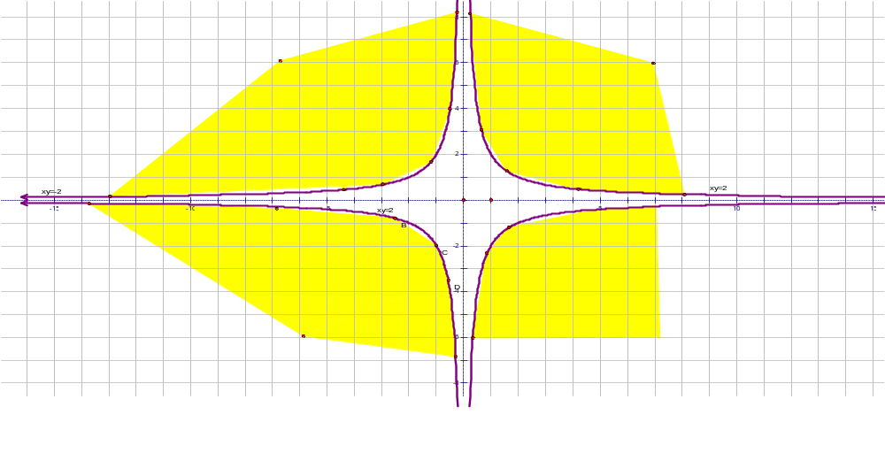
xy=2
xy=−2
xy=−2
1 mk for the graphs and 1 mk for the correct region.

(c) (i) Show that (1 + i) is a root of the polynomial P(x) = x³ + x² – 4x + 6. 2
If (1 + i) is a root then P(1 + i) = 0
P(1 + i) = (1 + i)³ + (1 + i)² −4(1 + i) + 6
= 1 + 3i + 3i² + i³ + 1 + 2i + i² – 4 – 4i + 6 1mk
= 4 + i – 3 – 1 – i = 0 1mk
∴ (1 + i) is a root of P(x).

(ii) Hence resolve P(x) into irreducible factors over the complex field. 3
Since P(x) has real coefficients ➔ the complex roots occur in conjugate pairs.
∴ ( 1 – i) is also a root. 1mk
∴ Let P(x) have roots (1 + i) , (1 – i) and β
Sum of the roots = (1 + i) + (1 – i) + β = −1 ➔ β = −3 1mk
∴ P(x) = (x + 3) { x − (1 + i)}{x − (1 – i)} 1mk

(d) Find the fourth roots of 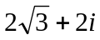. 5
Let z = x + iy be one of the fourth roots. Then z⁴ =
∴ z⁴ = 16(cos4θ + isin4θ) by De Moivre’s Theorem.
Equating the real parts ➔ 16cos4θ = 2 1mk
Equating imaginary parts ➔ 16sin4θ = 2 1mk
∴ tan4θ = 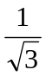 1mk ➔ 4θ = 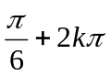, where k are integers.
∴ θ = 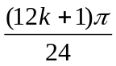, where k = 0, 1, −1, −2 1mk
∴ Four roots are: 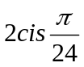, 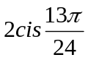, 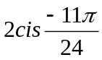, 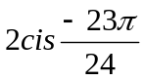 1mk

 END OF EXAM ☺

